Jedd Orsmond

Final Quality Prediction for Multiphase Batch Processes with Uneven  
Durations and Between-Phase Transient Dynamics

Project Outline

March 1, 2022

# Research Context

Multivariate Stasticial Process Monitoring (MSPM) is a common data-driven method for monitoring complex processes where mathematical models may be difficult or expensive to develop.

Many common multivariate statistical techniques such as PCA/PLS have been successfully applied to continuous processes for monitoring and diagnostic purposes as effective alternatives to conventional univariate stasticial process control.

Batch processes present a unique challenge inherently characterized by (Undey & Cinar, 2002):

1. Transient behaviour
2. Nonlinearity, process complexity and high dimensionality
3. Batch-to-batch variations and unequal lengths
4. Multiphase behaviour

Despite these challenges, batch processes continue to be a cost-effective method of producing low-volume and high-value products (LVHP) which would otherwise be uneconomical for continuous processes. Further warranting the need for proper process monitoring and diagnostic methods.

## BATCH PROCESS CHALLENGES

## Transient Behaviour

MSPC with PCA/PLS, as applied to continuous processes, consider the signals to be statistically stationary and not change with time – which is typically not satisfied by batch/semi-batch processes.

Batch processes are non-steady, time-varying with a finite duration where variable trajectories and set-points change over time from an initial value to a final value.

PCA/PLS were extended to batch processes with the pioneering work of Multiway-PCA* (and later MPLS) by McGregor (1995) which decomposed (“Unfold”) three-way data of batch processes.

*sometimes referred to as “Unfolded”-PCA.

## (2) Non-Linearity, (3) Batch-to-Batch Variations, (4) Unequal Lengths

The relationship between process variables does not typically follow a linear behaviour and change during batch evolution.

Variations between batches also arise due to changes in initial conditions, process disturbances and timing of key interventions by operators. These variations means that for a real batch process the length is often not fixed and will continue to run until a certain quality parameter is achieved.

Subsequently various improvements to MPCA/MPLS were proposed to account for factors such as dynamic characteristics, nonlinearity, non-gaussian distributions etc. ( DPCA, KPCA, HPCA, BDPCA etc.)

## (5) Multiphase Behaviour

Many industrial processes will exhibit multiphase behaviour where each phase has its own characteristic dynamics and underlying process variable correlations.

These phases arise when a batch goes through multiple processing units, or through chemical and phenomenological actions (chemical reaction kinetics, microbial growth phases) which affect the underlying process correlations.

Most batch processes exhibit multiphase behaviour arising from sequence of multiple steps in a single processing unit; or chemical and phenomenological actions (chemical reaction kinetics, microbial growth activity).

Monolithic models based on traditional MPCA/MPLS cannot effectively capture the multi-phase behaviour. In addition, not all variables are present at each stage of a batch process meaning models had to be simplified or missing data had to be imputated.

## LITERATURE DIRECTION

In recent years the challenge of multiphase behaviour, between-phase transitions and unequal batch length have received increasing attention in the literature, summarised:

1. **Multiphase behaviour**
   * Most batch processes are inherently multiphase
   * Statistical correlation between varables characteristic of each phase
   * Some variables are not available in each phase
2. **Between-phase transitions**
   * The region between two adjacent phases are associated with increased uncertainty
   * This may lead to incorrect phase assignment of a given data sample and inaccurate prediction
   * Differences in batch length and alignment of key sequences/steps can contribute to the uncertainty in between phases
3. **Unequal batch lengths**
   * Batches may continue to operate until a certain quality parameter is achieved
   * Batch-to-batch variations (initial conditions, disturbances etc.) make it common for industrial batch processes to vary in length and timing of key events
   * This may affect the performance of phase division techniques

These are discussed in more detail in the Literature overview.

## LITERATURE OVERVIEW

### Multiphase Behaviour

The generally accepted approach to dealing with batch processes that exhibit multiphase behaviour is to partition the process into multiple phases and modelling each phase seperately. In doing so, the problem of missing variables in different phases and shifting variable correlations can be addressed.

Local MPCA models are widely employed for process monitoring (Camacho & Picó, 2006; Zhaomin et al., 2014). PCA is used to extract the major variance, remove collinearity and setup monitoring residuals such as T2 for fault detection. Recently, the use of canonical correlation analysis (CCA) and independent component analysis (ICA) have also received attention (Z. Chen et al., 2016; Lee et al., 2003).

Quality-related prediction or KPI process monitoring is commonly performed with MPLS models (J. Chen & Liu, 2002; Ündey et al., 2003; David Wang, 2011).

Much recent research has opted for a probabilistic approach to better account for process uncertainty. (Z. Chen et al., 2016) integrated a BIP index to reduce false-positives in their fault detection models. (Liu et al., 2018; Yang et al., 2016; Yu, 2012; Yu, Chen, & Rashid, 2013) have opted for local Gaussian Process Regression (GPR) models over deterministic models such as PLS.

### Phase Detection

With the multi-model approach becoming widely accepted approach for multiphase batch processes, the manner in which the process is partitioned becomes the critical step. The main types of partitioning methods are (1) Knowledge-based, (2) Analysis-based and (3) data-driven.

Considering that the goal is to partition the process into phases to capture changes in covariance structures, not necessarily what is logical from an operational perspective, the use of data-driven techniques is preferred. These do not rely on process knowledge and are easier to implement. Further, the partitioning is based directly on correlation structures which ensures that phases are only partitioned when necessary.

Early work relied on expert-knowledge to divide the process logically - (Doan & Srinivasan, 2008) performed phase division according to specific expert knowledge and analysis of the units. Later, the use of Singular Points (SP) were employed for phase identification. A variety of algorithims have been proposed such as Sub-PCA (Zhao et al., 2007), Stage-based PLS (Lu & Gao, 2005), MP Algorithm (Camacho & Picó, 2006) have also been employed in what is essentially a clustering exercise.

Much of the recent attention has been based on Gaussian mixture models (GMM) for phase detection to much success in what is essentially a clustering exercise (T. Chen & Zhang, 2010; Guo et al., 2020; Jiang & Yan, 2019; Liu et al., 2018; Yao et al., 2012).

#### Singular Points

Singular Point (SP) analysis is based on local extrema points which tend to reflect important points in the process corresponding to phase changes. A representative batch from historical database (“golden batch”) and key-variable (e.g. temperature) is chosen to segment the process into phases (Doan & Srinivasan, 2008). Phase identification is done online by comparing incoming sample to the golden batch reference.

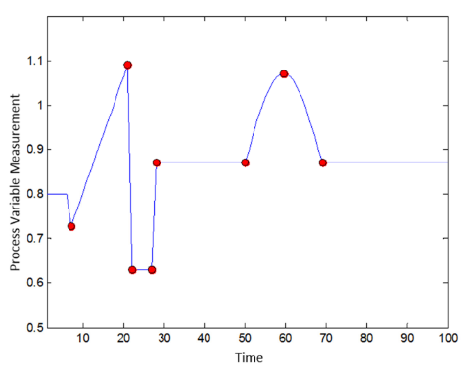

Figure 1 - variable trajectory showing singular points

#### Stage-based PLS

Stage-based PLS analysis (extension of Sub-PCA method) partitions a process into phases based on major changes to the regression parameter matrix (weighting) which would indicate a change in correlation phase (Lu & Gao, 2005).

The process is split into several ‘time-slices’ by building PLS models for every one of **K** time intervals. These time-slices are then divided into phases (similar correlation structures) using a k-means algorithim. A threshold can be introduced to combine merge clusters with close centers, this offers a balance between number of clusters and model accuracy.

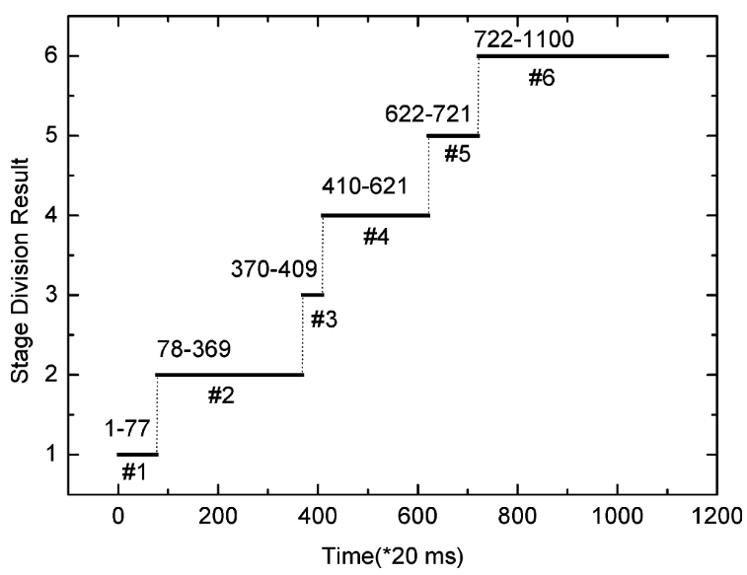

Figure 2: example phase division for injection moulding process (Lu & Gao, 2005)

#### Gaussian Mixture Models

Considering the multiphase characteristics of a batch process the data in its entirety will often present as a non-Gaussian distribution but can be divided into phases represented by an approximate multivariate Guassian distribution.

GMM is a probabilistic model that assumes all the data points can be described from a finite linear combination of Gaussian distributions with unknown parameters.

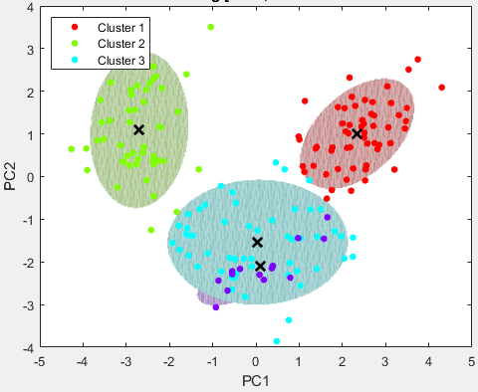

Figure 3 – GMM clustering of latent batch data

In order to establish the GMM, the expectation maximization (EM) algorithim is used to estimate the unknow model parameters. The EM algorithm guarentees that a local optimal point is found but does not guarantee that this is the global optimal. In this case, the number of components for the GMM can have a significant effective on performance.

The Bayesion Information criterion (BIC) and Akaike Information criterion (AIC) can be used to efficiently select the number of components based on an ‘elbow’ method.

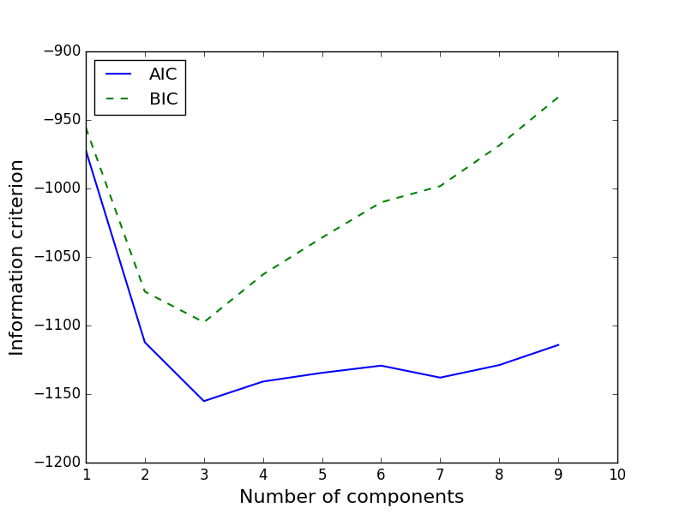

Figure 4: example plot of AIC and BIC for various GMM components

Many alternatives have been suggested to automatically specify the number of components such as Finite-GMM, GMM-PSD, and the Figueiredo-Jain (FJ) algorithm (Liu et al., 2018). Variational Bayesian GMM (VB-GMM) is also an effective technique that regards the number of clusters as a parameter to be optimized and does so by introducing Variational inference into the EM algorithm (Jiang & Yan, 2019).

(Yu, Chen, Mori, et al., 2013) employed a GMM based phase detection method with kernel functions to identify operating phases. A threshold was introduced to determine ‘fuzzy’ regions in which the Gaussian distributions overlapped representing between-phase transitions.

(Liu et al., 2018) implemented GMM-PSD with the FJ algorithm to develop a performance assessment model based on local GPR models for multiphase batch processes. Batches with unequal length were considered and the overlapping regions determined by PSD was used to identify a ‘fuzzy’ transitional region between phases.

(Jiang & Yan, 2019) implemented a VB-GMM clustering to identify phases for a penicillin fermentation process and develop local CCA models for fault detection.

#### Phase Assigment

On-line phase assignment for GMM-based division is achieved by calculating the posterior probability of a new data sample w.r.t. each Gaussian component. The phase with the highest probability is taken to be the current phase and the corresponding local model is invoked.

### Between-Phase Transition Regions

While a multi-model approach to multiphase batch processes show great performance improvement over traditional monolithic models there is often increased uncertainty or rate of false positives at the transition point between phases.

Industrial historical batch data has batch-to-batch variations arising from changes in initial conditons, process distrubances, timing of key steps by operator and total batch length. These variations are concentrated at the transitions points between phases. The associated incorrect state estimation will cause inaccurate quality predictions or false positives.

#### Alignment

Alignment of batch data before clustering can reduce the uncertainty between phase boundaries. One method is to use an **indicator variable (IV)**, instead of time, as the measure of batch evolution. Commonly used IVs are conversion, percentage of ingredient fed. This method is easy to implement but such a variable may not always exist or be easily identified.

A widely used alternative for this purpose is **dynamic time warping (DTW).** DTW is an algorithm originally developed for speech recognition which can align and map a two signals to a standard time axis. This method will translate, compress and expand a pair of signals in such a way that the diffence between them is minimized. (X. Chen et al., 2010; Doan & Srinivasan, 2008)

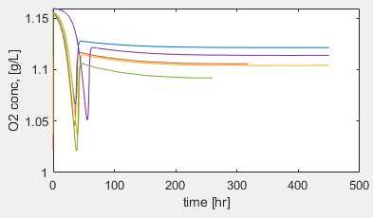 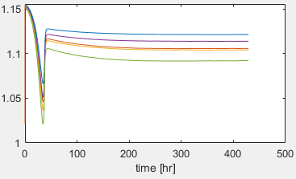

Figure 5: batch data before and after alignment

#### ‘Fuzzy’ Identification

In some cases the pre-processing alignment step is omitted in favour of a different approach where the uncertain or transition regions are identified directly and treated as ‘fuzzy’ phases. Local models are then developed for these fuzzy regions to improvement overall performance.

(Zhao et al., 2007) proposed **soft-transition-MPCA (STMPCA)** to overcome the disadvantages of the traditional strict sub-PCA phase division algorithm. In this approach, the transitions between phases are handled in a smooth manner.

(Luo, 2019) proposed *TBFPP* method to directly identify transition regions between adjacent phases. Phases are classified into ‘steady’ and ‘transition’ phases based on membership threshold and further local models are developed for these.

(Yao et al., 2012) implemented GMM-based clustering with a confidence threshold (95%) placed on the posterior probability as a means of classifying ‘steady’ and ‘transition’ phases. In transition phases, further local models are developed.

#### Bayesian Model Averaging

Instead of treating the transition regions explicity with additional local models, **Bayesian Model Average (BMA)** can be adopted and an extension of the ‘fuzzy’ identification approach.

This technique will use the posterior probability as a dynamic weighting for sample points that lie within a ‘fuzzy’ region. This provides a weighted prediction by invoking and dynamically weighting the outputs of both adjacent phase models (Liu et al., 2018; Yu, Chen, & Rashid, 2013).

(Liu et al., 2018) implemented soft-GMM for phase identification of batch data. The overlapping indices of adjacent Gaussians were used to specify fuzzy regions in which the output of a given sample would be weighted dynamically using BMA as opposed to developing additional models.

# Project OVERVIEW

## PROJECT TITLE

***Gaussian Process Regression*** *and* ***Bayesian Model Averaged*** *based Online* ***Quality Prediction*** *for* ***Multiphase*** *Batch Processes with* ***Uneven Duration*** *and* ***Between-Phase Transient Dynamics***

## PROJECT BREAKDOWN

|  |  |  |
| --- | --- | --- |
| **Step** | **Technique** | **Comment** |
| Data Generation | Fed-Batch Penicillin in Simulink | Benchmark for batch process monitoring   * Inherently multiphase & nonlinear * Variations in initial conditions * Noise on certain signals * Time delays in quality measurements (Z.O.H) * Variation in timing of key sequences |
| **Data Pre-Processing** | | |
| Alignment | DTW/IV | Performed comparatively with DTW and Indicator Variable (IV)   * Assymmetic DTW with optimal warping window * Indicator Variable – % Volume change |
| Unfolding | Variable-wise | Variable-wise to account for unequal lengths |
| Dimensional Reduction | PCA | Reduce 11 input variables to lower dimension |
| **Offline Modelling** | | |
| Phase Detection | K-means, DBSCAN, GMM | K-means and DBScan used as a screening input for number of clusters.  Soft-GMM integrated with AIC and BIC for final selection. Non-shared covariance structures if viable. |
| Local Predictive Model | GPR | GMM produces phases with mostly guassian distributions, probababilistic GPR models complement this. |
| **Online Monitoring** | | |
| State Estimation | GMM | Posterior probability determine from posterior probability |
| Quality Prediction | BMA | Final model output weighted dynamically with adjacent Gaussian posterior probabilites |

## PROJECT APPROACH

Figure 6 – Bayesian Model Average (BMA) strategy for online phase assignment (Yu, Chen, Mori, et al., 2013)

## PROJECT ROADMAP

Generalized list of tasks to be completed.

1. **Data Generation**
   1. ~~Build Simulink model for Penicillin Fermentation Process~~
   2. ~~Validate results against Literature~~
   3. ~~Generate Historical data~~
      1. ~~Add variations in initial conditions~~
      2. ~~Add noise on specific signals~~
      3. ~~Add time-delay for specific quality measurements~~
      4. ~~Add variation in timing of sequences~~
   4. ~~Generate Golden batch~~
2. **Data Preprocessing**
   1. Outlier indentification and removal (not applicable)
   2. ~~Align batch trajectories~~
      1. ~~Using DTW~~
      2. ~~Using Asymmetric DTW~~
         1. ~~Implement warping window~~
      3. ~~Using IVs~~
   3. ~~Unfold batch data~~
      1. ~~Variable-wise~~
      2. Batch-wise (deferred)
   4. ~~Scale and normalize data~~
   5. ~~PCA for dimensional reduction~~
      1. ~~Generate explained variance plot~~
      2. ~~Elbow selection~~
3. **Offline Modelling**
   1. Phase detection
      1. ~~Implement K-means~~
      2. ~~Implement DBScan~~
      3. ~~Implement soft-GMM~~
      4. ~~Incorporate BIC/AIC around initial guess~~
      5. Determine boundary regions for stable and fuzzy phases
   2. Local Model Development
      1. Implement GPR models for each phase
4. **Online Monitoring**
   1. Implement function hook into Simulink process
   2. Phase Assignment
      1. Determine posterior probability
   3. **Predict Quality**
      1. Invoke corresponding local models
      2. Weight prediction dynamics with Bayesian Model Average
5. **Performance Evaluation**
   1. Assess quality prediction vs. actual value

# Brief Literature reviews

**(Jiang & Yan, 2019) – *“Multimode Process Monitoring Using Variational Bayesian Inference and Canonical Correlation Analysis”***

* As applied to batch-fed penicillin fermentation process
* Used the VB-GMM algorithm to automatically perform phase division from historical data without specifying the number of operation modes…7 phases identified
* Establishes local CCA models (PCA alternative) for monitoring purposes
* During monitoring, the current operating phase is identified by largest posterior probability
* Local CCA model is used to determine the fault residuals, a BIP monitoring index is incorporated
* 100 batches of fixed 400hr length are generated, sampling time of 1hr
* 3 faulty batches were generated
  + 1. Step change introduced in agitator power from t=150hr -> 300hr
  + 2. Ramp change introduced in agitator power from t=150hr -> 300hr
  + 3. Ramp change introduced to aeration rate from t=150hr -> 300hr
* The proposed solution showed effective fault monitoring with the advantage of automatically determining the number of operation modes (which makes it more practical). CCA performance was shown to be superior to PCA for this implementation and incorporation of BIP monitoring index allows for monitoring in a probabilistic manner instead of deterministic.

**(Liu et al., 2018) – *“Gaussian Process Regresion and Bayesian Inference Based Operating Performance Assessment for Multiphase Batch Processes”***

* As applied to batch-fed penicillin fermentation process
* Used the GMM-PSD algorithm to automatically perform phase division from historical data without specifying the number of operation modes…5 phases identified
* Established local Gaussian Process Regression (GPR) models for each local phase
* From the results of offline phase division, the boundary intervals of adjacent phases overlap which is defined as ‘fuzzy intervals’. The cut-off is defined using a threshold value for the posterior probability
* During monitoring, the current operating phase is determined from the intervals as determined offline
* If the sample falls within a fuzzy interval, both adjacent local GPR models are invoked and the prediction is weighted by the posterior probability in each phase as calculated (Bayesian Model Averaging)
* An economic index is defined that defines whether a batch is current ‘optimal’ or ‘sub-optimal’. This is determined by the ratio of the current quality prediction to the min/max as determined from historical data. Values >0.5 are defined as ‘optimal’.
* Author further performs ‘non-optimal cause identification’
  + If performance is non-optimal, the possible cause is determined calculating variable contribution values
  + The calculated values are adjusted again into ratios of min/max as per historical data
* 50 training batches generated lengths of 390hr to 420hr, sampling time 1hr
* Sub-optimal/fault batch produced by using a culture volume of 150L – larger volumes experience evaporative loss since temperature is fixed which results in penicillin decline
* Prediction quality was shown to perform well, but from what I see the initial ramp up is not captured
* Sub-optimal batch was identified and variable contribution indicated Culture Volume as the likely cause

**(Yu, Chen, Mori, et al., 2013) – “*Multi-kernel Gaussian Process Regression and Bayesian Model Averaging Based Nonlinear State Estimation and Quality Prediction of Multiphase batch Processes”***

**Similar paper (Yu, Chen, & Rashid, 2013).**

* As applied to poylmerization process
* Offline phase division achieved using a kernel mixture model, individual phases are expressed by a local kernel density function (Gaussian density functions are used)
  + Bayesian inference is used to classify measurements into phases based on maximum posterior probability
  + If it satisfies a threshold (0.05) it is taken to be a certain phase, not between-phase transition
* Local GPR models are developed for each identified phase, a kernel function is incorporated to improve performance for nonlinear process
* During monitoring, current operating phase is determined by posterior probability
* If it falls within a transition region, a BMA is used where the prediction of adjacent phases are weighted dynamically based on the posterior probability
* 20 training batches, all fixed length of 3hr, sampling period 1 min
* The approach showed effective quality prediction better or comparable to SVR

**(Doan & Srinivasan, 2008) – “*Online monitoring of multi-phase batch processes using phase-based multivariate statistical process control”***

* As applied to batch-fed penicillin fermentation process
* Offline phase division achieved using Singular points in key variables along
  + 5 phases were detected
  + Golden batch was selected as a batch of 400hr length
* Run-to-run variations among different instances of a phase are synchronized using DTW
* Local dynamic-PCA models are developed for monitoring purposes (as an extension of PCA which incorporates a time-lag that is used to capture serial correlation in the process)
* During monitoring, for a given new sample, the sample is checked if it’s a Singular point
  + If it is, a phase change is flagged and the corresponding MSPC model is retrieved
  + If it is not, the monitoring statistics T2 is calculated for key variables and compared with a threshold from historical data to announce a fault if exceeded.
  + A time-lagged data matrix is constructed and a further T2 is calculated for comparison.
* 14 batches of data were generated with random initial condition and set points
* Batch lengths of 380-420hr, sampling time 0.5hr
* Batch lengths were cut-off to the longest common length since DPCA required equal length
* 4 fault batches were generated for testing:
  + 15% step increase in substrate feed rate from t=150hr to end
  + 15% step decrease in substrate feed flow rate t=160hr to end
  + 15% step decrease in agitation power from t=20hr to 40hr
* The Singular Point phase decomposition did not show great performance. A false positive was flagged in a test batch at t=88hr until t=93hr
  + This is a result of variations in initial conditions affecting the location of SPs

**(Yu, 2012) – “*online quality prediction of nonlinear and non-Gaussian chemical processes with shifting dynamics using finite mixture model based Guassian process regression approach”***

This paper takes a continuous process and uses a technique similar to GMM-based phase identified in batch processes to identify different operating **modes** of the continuous process.

* As applied to Tennessee Eastman chemical process
* Offline mode division using finite mixture model (FMM) where number of components is specified manually…6 were identified
* Nonlinear lernel function is selected for Gaussian process regression models (Gaussian kernel function is used).
* During monitoring, for any new input measurement, the data is normalized using the mean and std deviation from the training set
* The posterior probability is calculated with all identified operating modes
* The quality prediction of the test sample within each operating mode is estimated from the local Guassian process regression model
* The overall quality variable predicted is computed by incorporating all localized estimations within different operating modes – weighted by their posterior probabilities
* 2 test cases used:
  + Case 1 – data could belong to any of 3 operating modes
  + Case 2- operated under all 6 modes with random switching between
* Case 1 was identified and quality predicted accurately
* Case 2 showed improved performance compared to LSSVM approach with comparable accuracy as in Case 1

**References:**

Camacho, J., & Picó, J. (2006). Online monitoring of batch processes using multi-phase principal component analysis. *Journal of Process Control*, *16*(10), 1021–1035. https://doi.org/10.1016/j.jprocont.2006.07.005

Chen, J., & Liu, K. C. (2002). On-line batch process monitoring using dynamic PCA and dynamic PLS models. *Chemical Engineering Science*, *57*(1), 63–75. https://doi.org/10.1016/S0009-2509(01)00366-9

Chen, T., & Zhang, J. (2010). On-line multivariate statistical monitoring of batch processes using Gaussian mixture model. *Computers and Chemical Engineering*, *34*(4), 500–507. https://doi.org/10.1016/j.compchemeng.2009.08.007

Chen, X., Gao, X., Zhang, Y., & Qi, Y. (2010). Enhanced batch process monitoring and quality prediction based on multi-phase multi-way partial least squares. *Proceedings - 2010 IEEE International Conference on Intelligent Computing and Intelligent Systems, ICIS 2010*, *2*(3), 32–36. https://doi.org/10.1109/ICICISYS.2010.5658834

Chen, Z., Ding, S. X., Zhang, K., Li, Z., & Hu, Z. (2016). Canonical correlation analysis-based fault detection methods with application to alumina evaporation process. *Control Engineering Practice*, *46*, 51–58. https://doi.org/10.1016/j.conengprac.2015.10.006

Doan, X. T., & Srinivasan, R. (2008). Online monitoring of multi-phase batch processes using phase-based multivariate statistical process control. *Computers and Chemical Engineering*, *32*(1–2), 230–243. https://doi.org/10.1016/j.compchemeng.2007.05.010

Guo, W., Pan, T., Li, Z., & Chen, S. (2020). Batch process modeling by using temporal feature and Gaussian mixture model. *Transactions of the Institute of Measurement and Control*, *42*(6), 1204–1214. https://doi.org/10.1177/0142331219887827

Jiang, Q., & Yan, X. (2019). Multimode Process Monitoring Using Variational Bayesian Inference and Canonical Correlation Analysis. *IEEE Transactions on Automation Science and Engineering*, *16*(4), 1814–1824. https://doi.org/10.1109/TASE.2019.2897477

Largoni, M., Facco, P., Bernini, D., Bezzo, F., & Barolo, M. (2015). Quality-by-Design approach to monitor the operation of a batch bioreactor in an industrial avian vaccine manufacturing process. *Journal of Biotechnology*, *211*, 87–96. https://doi.org/10.1016/j.jbiotec.2015.07.001

Lee, J. M., Yoo, C., & Lee, I. B. (2003). On-line batch process monitoring using different unfolding method and independent component analysis. *Journal of Chemical Engineering of Japan*, *36*(11), 1384–1396. https://doi.org/10.1252/jcej.36.1384

Liu, Y., Wang, X., Wang, F., & Gao, F. (2018). Gaussian Process Regression and Bayesian Inference Based Operating Performance Assessment for Multiphase Batch Processes. *Industrial and Engineering Chemistry Research*, *57*(21), 7232–7244. https://doi.org/10.1021/acs.iecr.8b00234

Lu, N., & Gao, F. (2005). Stage-based process analysis and quality prediction for batch processes. *Industrial and Engineering Chemistry Research*, *44*(10), 3547–3555. https://doi.org/10.1021/ie048852l

Luo, L. (2019). Monitoring Uneven Multistage/Multiphase Batch Processes using Trajectory-Based Fuzzy Phase Partition and Hybrid MPCA Models. *Canadian Journal of Chemical Engineering*, *97*(1), 178–187. https://doi.org/10.1002/cjce.23220

Undey, C., & Cinar, A. (2002). Statistical Monitoring of Multistage, Multiphase Batch Processes. *IEEE Control Systems*, *22*(5), 40–52. https://doi.org/10.1109/MCS.2002.1035216

Ündey, C., Ertunç, S., & Çinar, A. (2003). Online batch/fed-batch process performance monitoring, quality prediction, and variable-contribution analysis for diagnosis. *Industrial and Engineering Chemistry Research*, *42*(20), 4645–4658. https://doi.org/10.1021/ie0208218

Wang, D., & Srinivasan, R. (2009). Multi-model based real-time final product quality control strategy for batch processes. *Computers and Chemical Engineering*, *33*(5), 992–1003. https://doi.org/10.1016/j.compchemeng.2008.10.022

Wang, David. (2011). Robust data-driven modeling approach for real-time final product quality prediction in batch process operation. *IEEE Transactions on Industrial Informatics*, *7*(2), 371–377. https://doi.org/10.1109/TII.2010.2103401

Yang, K., Jin, H., Chen, X., Dai, J., Wang, L., & Zhang, D. (2016). Soft sensor development for online quality prediction of industrial batch rubber mixing process using ensemble just-in-time Gaussian process regression models. *Chemometrics and Intelligent Laboratory Systems*, *155*, 170–182. https://doi.org/10.1016/j.chemolab.2016.04.009

Yao, Y., Dong, W., Zhao, L., & Gao, F. (2012). Multivariate statistical monitoring of multiphase batch processes with between-phase transitions and uneven operation durations. *Canadian Journal of Chemical Engineering*, *90*(6), 1383–1392. https://doi.org/10.1002/cjce.21617

Yu, J. (2012). Online quality prediction of nonlinear and non-Gaussian chemical processes with shifting dynamics using finite mixture model based Gaussian process regression approach. *Chemical Engineering Science*, *82*, 22–30. https://doi.org/10.1016/j.ces.2012.07.018

Yu, J., Chen, K., Mori, J., & Rashid, M. M. (2013). Multi-kernel Gaussian process regression and Bayesian model averaging based nonlinear state estimation and quality prediction of multiphase batch processes. *Proceedings of the American Control Conference*, 5451–5456. https://doi.org/10.1109/acc.2013.6580690

Yu, J., Chen, K., & Rashid, M. M. (2013). A Bayesian model averaging based multi-kernel Gaussian process regression framework for nonlinear state estimation and quality prediction of multiphase batch processes with transient dynamics and uncertainty. *Chemical Engineering Science*, *93*, 96–109. https://doi.org/10.1016/j.ces.2013.01.058

Zhao, C., Wang, F., Lu, N., & Jia, M. (2007). Stage-based soft-transition multiple PCA modeling and on-line monitoring strategy for batch processes. *Journal of Process Control*, *17*(9), 728–741. https://doi.org/10.1016/j.jprocont.2007.02.005

Zhaomin, L., Qingchao, J., & Xuefeng, Y. (2014). Batch process monitoring based on multisubspace multiway principal component analysis and time-series bayesian inference. *Industrial and Engineering Chemistry Research*, *53*(15), 6457–6466. https://doi.org/10.1021/ie403576c